Stem cell transplant restores memory and learning in mice
By Tim / 23 April 2013 /
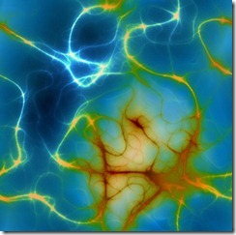
In a tantalising research first, human embryonic stem cells (hESCs) have been successfully transplanted into the brains of mice and then shown to restore memory and learning, according to scientists at the University of Wisconsin-Madison. The research was published online in Nature Biotechnology on 21 April 2013.
Dysfunctional basal forebrain cholinergic neurons (BFCNs), present in the medial ganglionic eminence (MGE) of the brain, are often implicated in memory and learning disorders like Alzheimer’s disease and Down syndrome. To see if a stem cell transplant could repair BFCNs in neurologically-deficient mouse models, the researchers differentiated hESCs into MGE-like progenitor cells and transplanted these into the hippocampi of mice with damaged medial septa. The MGE-like progenitors were able to produce basal forebrain cholinergic neurons (BFCNs) that then made connections with endogenous neurons in the hippocampus. The researchers were also able to use progenitor cells to similarly generate γ-aminobutyric acid (GABA) neurons.
“These two neuron types are involved in many kinds of human behavior, emotions, learning, memory, addiction and many other psychiatric issues,” said senior author Su-Chun Zhang, a professor of neuroscience and neurology. “This circuitry is fundamental to our ability to learn and remember.”
The mice transplanted with the progeny of MGE-like progenitors showed significant improvement in tests of learning and memory, such as becoming more adept at the water maze test. The researchers write that the findings support the prospect of using human stem cell–derived MGE-like progenitors in developing therapies for neurological disorders of learning and memory.

